**Problems with Procedural Programming**

Session: 2022-2026

**Name:** Muhammad Saad Akmal

**Registration Number**: 2022-CS-148

**Submitted to:**  Professor Awais Hassan

Department of Computer Science

**University of Engineering and Technology**

**Lahore Pakistan**

# **Disjoint data:**

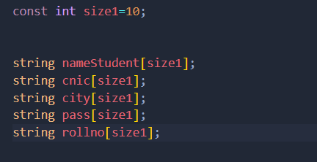

**Figure 1 Disjoint Arrays**

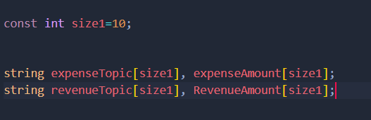

**Figure 2 Constraint on Data**

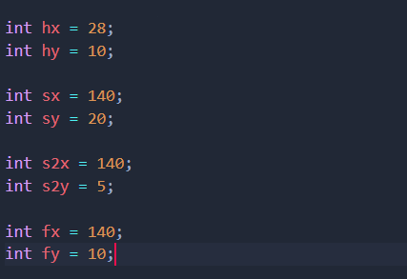

**Figure 3 Maintainability**

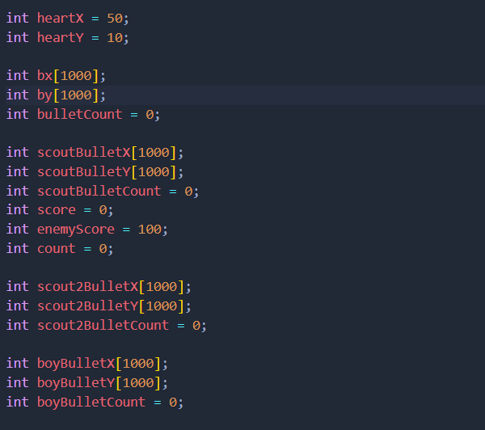

**Figure 4 High Coupling**

# **Extending the functionality:**

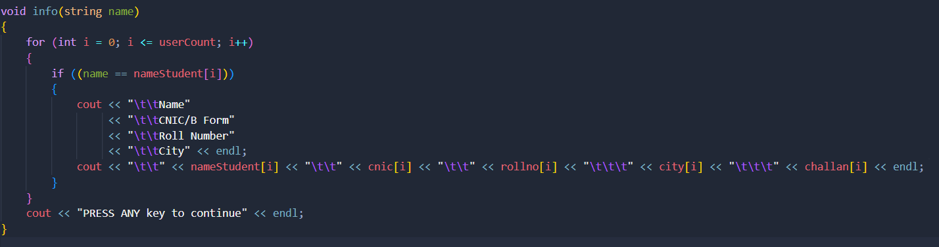

***Figure 5(a) Extending Functionality***

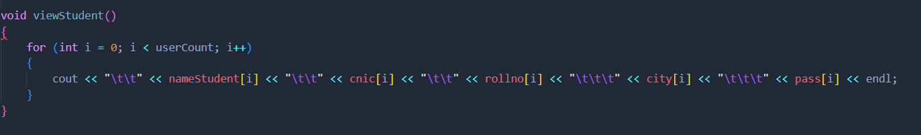

***Figure 5(b) Extending Functionality***

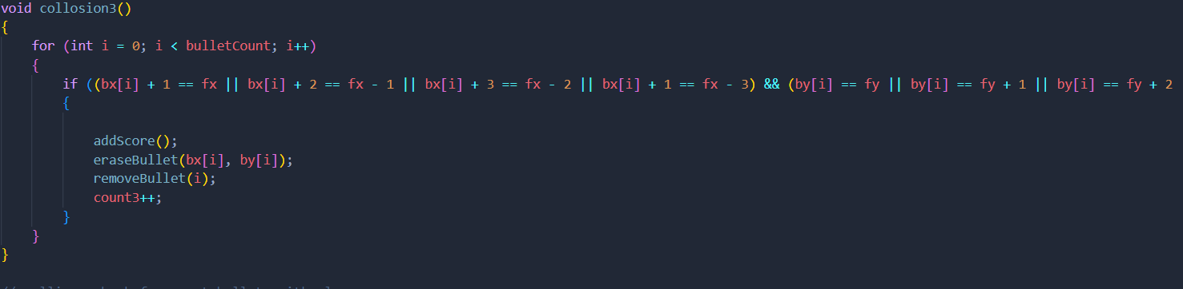

***Figure 6(a) Extending Functionality***

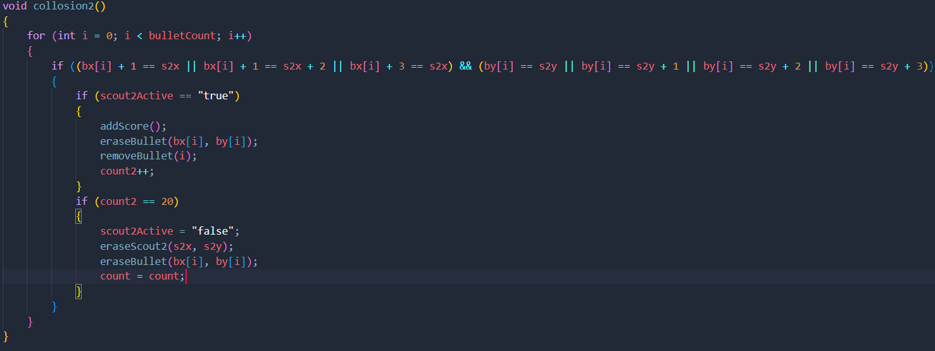

***Figure 6(b) Extending Functionality***